6/25/2020

Quan Le

Meiko towada vietnam.

**CORE API SYSTEM**



**Core API System Building Proposal**

1. **Overview**

Currently, there are many software which have been operating in MTV. In details, number of software bought from outside is 5 (belong and manage by ICT Department), 20 software were developed by ourselves SE Department. Every single self developed software is operating independency with 1 database. With a fast growing business, it becomes extremely challenging to manage, maintain the records of database manually. Maybe it’s a part of cause grow down productivity database system of MTV.

Nowadays data plays a major role in any organization. Our company ensures our customer for reliability data. Asynchronous data of these software is raising a problem when we want to collect for analysing business operations.

As above reason we make a Proposal to build an API system, We want to provide a core system solutions to help concentrate data. This lessens the burden of the management and provides better data performance.

1. **Technical Requirements**

Base on RESTful API, it refers to an architectural style where web services receive and send data from and to client apps (With many devices, many type of applications). The goal of these applications is to centralize data that all client apps will use.

With 90% ourselves software made by SE member on C# , ASP .NET Framework, we choose ASP.NET Core framework which is the right tools to write RESTful API services is crucial since we need to care about scalability, maintenance, documentation, and all other relevant aspects.

**System Architecture**

***Before***

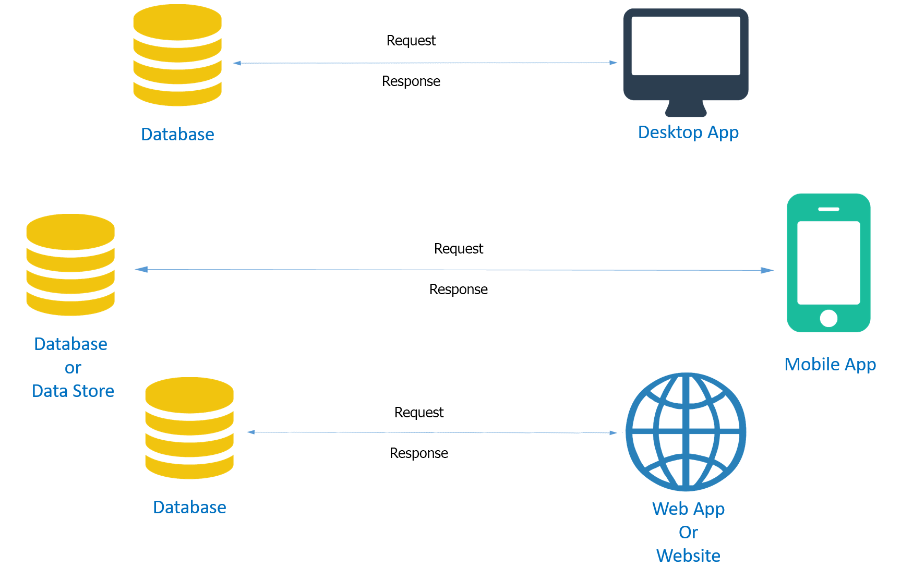

**Problem***:*

* Software is developed dispersal, difficult to manage database connections
* There is no inheritance for each other, difficult to be scalable. Difficult to maintain for wide area functional.
* Too many databases would create. Maybe it’s a part of cause grow down productivity database system of MTV.

***After***

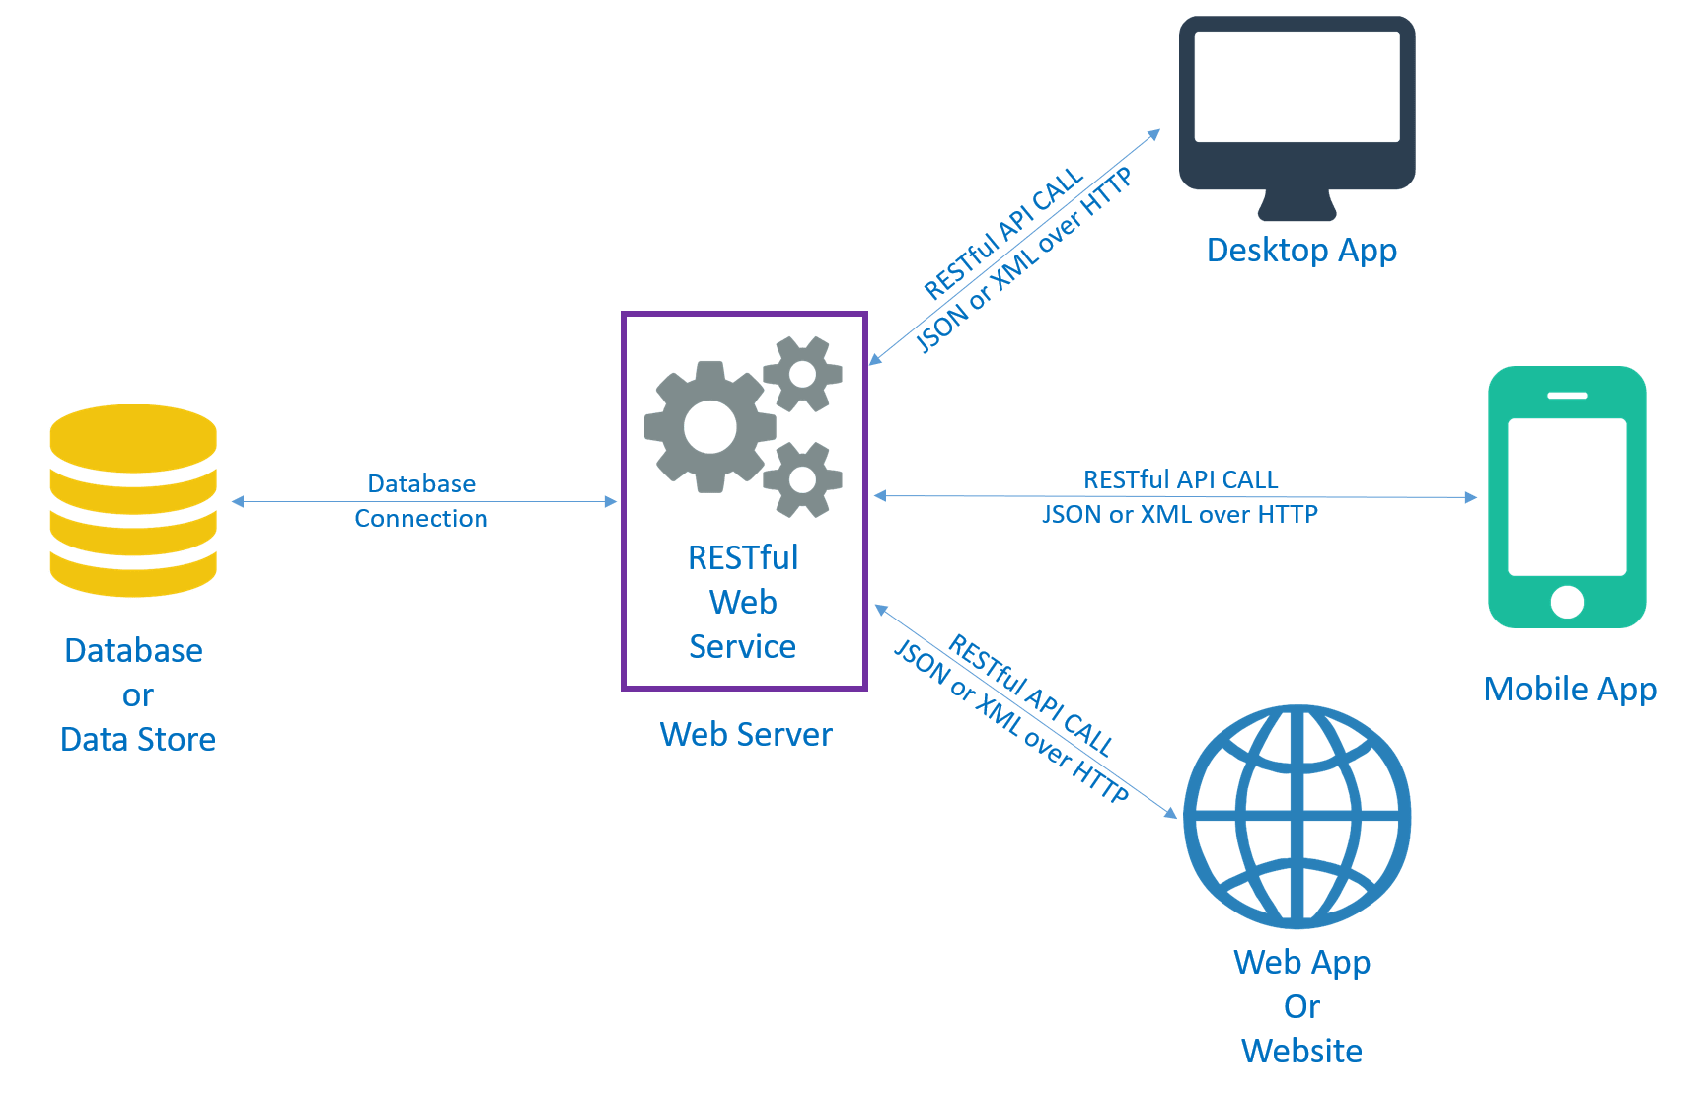

**What is RESTful API?**

RESTful API : (REpresentational State Transfer Application Program Interface) is based on representational state transfer (REST), an architectural style and approach to communications often used in web services development that uses HTTP requests to GET, PUT, POST and DELETE data.

**WHY RESTful API?**

**Due to its centralize data.** With 1 part of data from database we can provide for functional which are common in many software. It provides managing database connections abilities. This abilities guaranteed productivity of database working on good ways.

**Due to its scalability.** This protocol stands out due to its scalability. Thanks to the separation between client and server, the product may be scaled by a development team without much difficulty.

**Due to its flexibility and portability.** With the indispensable requirement for data from one of the requests to be properly sent, it is possible to perform a migration from one server to another or carry out changes on the database at any time. Front and back can therefore be hosted on different servers, which is a significant management advantage.

**Due to its independence.** Due to the separation between client and server, the RESTfull API makes it easy for developments across the various areas of a project to take place independently. In addition, the REST API adapts at all times to the working syntax and platform. This offers the opportunity to try several environments while developing.